1. Teams and Teamwork

The way a team plays as a whole determines its success. You may have the greatest bunch of individual stars in the world, but if they don’t play together, the club won’t be worth a dime.—Babe Ruth

Engineering projects are often very large and require too many diverse skills to be completed by a single person. This necessitates the use of teams, and it is likely that you will participate on many during your professional career. That is why employers of engineering graduates consistently rate teamwork ability as one of the most desirable attributes in a potential employee. Teams can collectively perform tasks that could not possibly be completed by individuals working in isolation. However, just because a team is created does not mean that it will function effectively, and examples of failed teams abound. When people learn that they are going to work on a team, their initial reaction is often one of dread, usually due to bad experiences in the past. The good news is that with some attention to team principles and a conscious effort, working on a team can be a positive experience. Much research has been done and much has been written on teams and teamwork. The objective of this chapter is to provide a primer on what constitutes a team, present models of team development, identify the characteristics of effective teams, and provide guidance for effective teamwork.

Learning Objectives

By the end of this chapter, the reader should:

* Understand the characteristics that define a team and understand why a team is formed.
* Understand different models for the stages of team development.
* Understand the characteristics of effective teams.
* Be able to develop Team Process Guidelines.

What is a Team?

The concept of a team is used broadly in many different contexts, so the following definition of a team proposed by Katzenbach and Smith in The Wisdom of Teams [Kat93] is provided for the basis of our discussion:

A small group of people with complementary skills, who are committed to a common performance, performance goals, and approach for which they hold themselves mutually accountable.

This concept of a team is highly relevant to engineering design projects.

The definition indicates that a team should be a small group of people, typically two to ten. Teams larger than this become very difficult to manage. The reason is that the number of relationships between people increases rapidly with an increase in the number of people on the team. The number of person-to-person relationships is equal to *n(n-1)/*2, where *n* is number of people on the team. Any one of these relationships can falter, causing problems. In addition, it is hard to develop consensus on important issues as the number of people on the team increases.

Second, the definition indicates that teams should be composed of members who have complementary skills. Members should be selected based upon the background and skills that each person brings to the team, not based upon personality and friendships. This leads to the related concepts of ***cross-functional*** and ***multi-disciplinary teams.*** Cross-functional teams are those that are composed of people from different organizational functions, such as engineering, marketing, and manufacturing [Wil95]. Cross-functional teams are particularly important in new product development, where multiple functions are required to bring a product from concept, to manufacture, and ultimately to the market. Multi-disciplinary implies that the team is composed of members from different disciplines. There is no agreement in the engineering community as to what exactly constitutes a multi-disciplinary team. In general, the idea of complementary skills applies where a team may have representation from multiple technical disciplines. For example, the development of a robot would require members with multi-disciplinary expertise in computing, electronics, and mechanical systems.

Third, the definition states that teams should have common performance goals. The goals take time to develop and the team will likely flounder in creating them, but without specific goals to achieve there is no need for a team. In the context of design, the team’s goals are defined by the Problem Statement and Requirements Specification developed in Chapters 2 and 3 respectively. They collectively state what the team is trying to achieve and provide a way for the team to verify its success—are the requirements met and can the team demonstrate that they are?

Finally, the team definition indicates that teams should have a common approach for which they hold themselves mutually accountable. This can be a common approach to solving problems, such as application of the design process. It can also be in terms of a method for holding the team members accountable. One of the biggest problems that teams face is handling situations where the team fails to meet a given objective. This may be due to one or more members failing to meet their commitments. The team must be able hold each other mutually accountable in a constructive manner in these situations.

Models of Team Development

Bruce Tuckman developed a model for team development that contains fives stages, known as forming, storming, norming, performing, and adjourning [Tuc65]. It is instructive to have an understanding of these stages so that you are aware of the dynamics that occur as a team develops. The five stages are described as follows:

* *Forming.* This is the stage where the team is created. The team members may not know each other, leading them to be anxious and uncomfortable. It is likely that the team’s objectives are not well-defined and that the members’ roles are ambiguous.
* *Storming.* In this stage, the team works to develop its objectives, while the members try to define their roles. Conflict often appears as members jockey for position and advantage. It is characterized by fighting and power struggles, which may be overt, but in many cases are subtle and below the surface. The team must resolve individual versus group goals. For example, what if the team is trying to select a project concept? Some members may have strong opinions and preconceived notions about what the project should be. Failure to navigate the storming stage means that the team will not reach the performing stage and will be forced to return to the storming stage at some time.
* *Norming.* In this stage the team starts to become more cohesive. Members accept the team’s objectives, their roles on the team, and they agree upon procedures. In this phase the team develops common approaches for solving problems and managing conflicts.
* *Performing.* In this stage, the team focuses on performing tasks and achieving the objectives set forth. The team should be collaborating and easily making decisions. Disagreements that arise are accepted and resolved by the team norms.
* *Adjourning.* Here, the team dissolves, hopefully due to successful project completion. However, it can occur abruptly if the project is cancelled, or even worse, if the team is unable to function together.

Katzenbach and Smith proposed the team performance curve in Figure 9.1, which shows the performance impact of teams versus varying levels of effectiveness. The types of teams they defined are the working group, the pseudo-team, the potential team, and the high-performance team. The most closely related stages of team development from the Tuckman model are indicated in parentheses on the figure. Notice that the scale on the x-axis is team effectiveness, not time. There may be an implicit assumption that teams will move through these stages as a function of the time the team is together. That is certainly a desired goal, but not necessarily what the model implies.

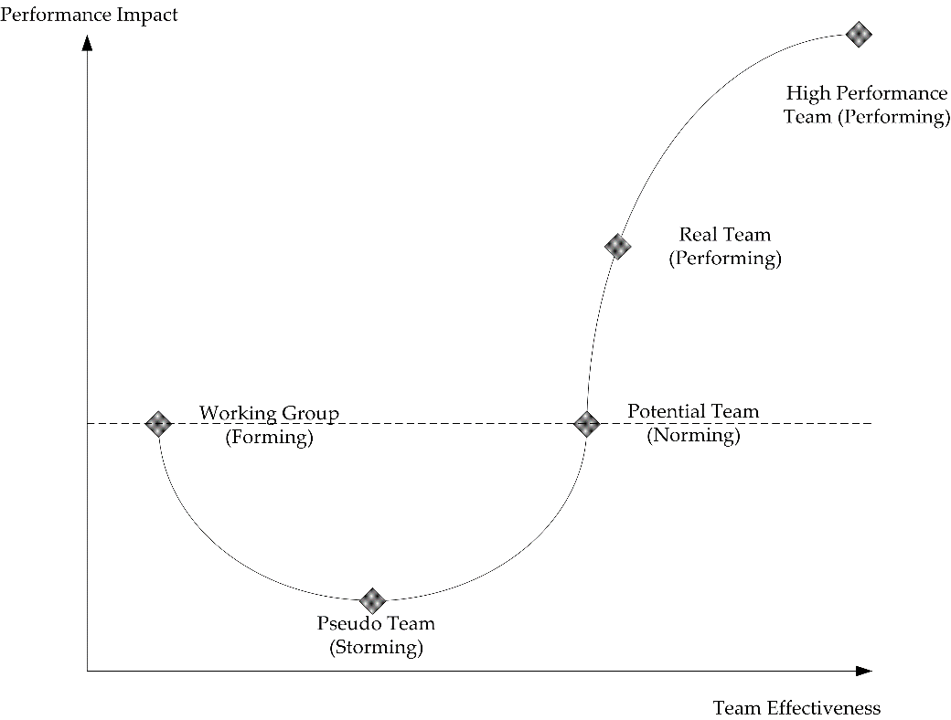

**Figure 9.1** The team performance curve proposed by Katzenbach and Smith [Kat93]. This shows the performance impact of teams versus varying levels of effectiveness. The Tuckman stages of team development (forming, storming, norming, performing) that are most closely related to the performance points are superimposed on the model [Tuc65].

The ***working group*** is defined as a group of individuals working in isolation, who come together occasionally to share information. In other words, if every member of the team works in isolation and meets only to share ideas, they would achieve the performance of the working group. This level of performance is represented by the dashed baseline. In fact, the working group is not a team as given by the definition and serves a very different purpose. The ***pseudo-team*** represents an under-performing team where the sum effort of the team is below that of the baseline performance, while the ***potential team*** is one in which the team is functioning at a level equal to that of the working group. At a minimum, teams should at some point perform above the level of a potential team, otherwise, there is no need for a team. The objective is to perform at the level of a ***real team,*** where the performance exceeds that of the working group. In rare instances the level of a ***high-performance team*** may be realized in which the team significantly outperforms all similar teams.

Characteristics of Real Teams

How can a team reach the performing stage and simultaneously become a real team? Unfortunately, there is no set process for guaranteeing that a team will become a real team. There are characteristics and principles of effective teams, and it has been observed that real teams apply these principles. However, realize that there is a difference between a team and teamwork principles. Real teams apply teamwork principles but this does not imply that the converse statement is true—that applying these principles will result in a real team. The lesson is that successful teams adhere to good teamwork principles, but the application of good teamwork principles does not automatically guarantee that teams will be successful. However, ignoring teamwork principles almost always leads to failure. The remainder of this section presents some of the characteristics of real teams.

### Select Members Based Upon Skills

Selecting team members based upon their skills is a key to success identified by Katzenbach and Smith. They defined three categories of relevant skills: 1) technical and functional, 2) problem-solving, and 3) interpersonal. The right mix of technical skills on a design project is important to achieve the desired objectives, reinforcing the need for multi-disciplinary and cross-functional teams. Different problem-solving approaches and the mix of interpersonal skills are important as well, but harder to determine. The Meyers-Briggs personality tests or the Keirsey Temperament sorter [Kei84] are tools that can be used to identify different problem-solving approaches and personality traits, but in themselves are not the answer for selecting teams.

One important point to consider is whether teams should be formed by self-selection or assigned by a supervisor. There are pro and con arguments for each method of selection. An argument for self-selection is that members believe the objectives of the team are important, leading to a higher level of commitment. A potential pitfall is that not enough attention is paid to the skills necessary to complete the project. In the second case, teams are assigned by someone who has an understanding of the skills needed for the project and assigns members accordingly. A potential pitfall is that this may create animosity from team members who are dissatisfied with the project from the outset.

### Identify Objectives

Teams are created to realize shared goals, and if the goals are not well-defined, the motivation for being part of the team is not clear. In the context of engineering design, the combined Problem Statement and Requirements Specification presented in Chapters 2 and 3 serve that purpose. The Problem Statement describes what the team is trying to achieve, while the Requirements Specification sets verifiable targets that define success. Both items are so important, that there should be a consensus agreement among the team members on their content. The team should be challenged by targets that are aggressive, yet achievable. Identifying measurable objectives was identified by Katzenbach and Smith as one of the most important attributes of successful teams. Further, all team members must be committed to achieving the objectives.

### Develop Decision-Making Guidelines

Teams regularly make decisions that affect all of its members and the success of the project. The team must determine how decisions are to be made, and once they are, all members need to accept the outcome. The team also needs to understand the importance of different decisions—not all are equally important and different approaches should be used depending upon the impact of the decision. Models for decision-making are outlined as follows [Joh02]:

1. *Decision by Authority*. The leader makes all decisions, typically without discussion by the rest of the team. This is effective for fast decision-making, but does often not lead to the best decision. It can also produce resentment among the team.
2. *Expert Member*. The most expert member on the subject decides. This is effective in cases where there is a single member who is clearly the expert on the subject.
3. *Average Member Opinion.* The average team member opinion is used. A method needs to be devised to determine what constitutes the average opinion.
4. *Decision by Authority after Discussion.* The leader makes a decision after all team members discuss the issue and provide input.
5. *Minority Control.* A few members act as a subcommittee and solve the problem. This makes sense if the minority group consists of experts on the particular problem.
6. *Majority Control.* A simple majority is used to make decisions.
7. *Consensus.* All team members must agree to and commit to the decision. This generally comes after much discussion and evaluation of the different alternatives. This is the best approach, and the most time-consuming. It is not necessary for all decisions to be made this way, but consensus should be reached for important decisions.

A formal and widely used method for brainstorming and team decision-making is known as the ***Nominal Group Technique*** (NGT) [Del71]. NGT was covered in Chapter 4 and is repeated here. In NGT, each team member silently generates solutions to a problem and the ideas are then reported out in a round-robin fashion until all ideas are exhausted. Then, each member gets to cast a predetermined number of votes for the ideas presented. The top idea is then selected, or alternatively, the top few ideas are discussed further and voted upon again. The steps of NGT are outlined below:

1. *Read problem statement.* It should be read out loud by a team member (the facilitator).
2. *Restate the problem.* Each person restates the problem in their own words to ensure that all members understand it.
3. *Silently generate ideas*. All members silently generate ideas during a set period of time, typically 5­–15 minutes.
4. *Collect ideas in a round-robin fashion*. Each person presents one idea in turn until all ideas are exhausted. The facilitator should clarify ideas and all should be written where the entire team can view them.
5. *Summarize and rephrase ideas.* Once the ideas are collected, the facilitator leads a discus­sion to clarify and rephrase the ideas. This ensures that the entire group is familiar with them. Related ideas can be grouped or merged together.
6. *Vote.* Each person casts a predetermined number of votes, typically three to six, for the ideas presented. The outcome is a set of prioritized ideas that the team can further discuss and pursue.

### Hold Effective Meetings

Teams need to meet for a variety of reasons, such as determining objectives, tracking progress, assigning tasks, preparing deliverables, and resolving problems. It is in these meetings that teamwork principles are most critical and where problems can arise. In the workplace it is estimated that people spend half of their time in tasks that are related to meetings (preparing, attending, and following up). Three elements of effective meetings are: 1) well-defined roles for the participants, 2) a structure for conducting the meeting, and 3) the application of interpersonal skills [Bel94]. Poorly organized and ineffective meetings lead to cynicism and poor team performance. The structure of meetings does not always need to be the same. Some keys to effective meetings are:

* *Have an agenda.* Agree upon the goals for a meeting in advance.
* *Show up prepared.* All members should show up on time with their tasks completed.
* *Pay attention.* Each person should speak in turn, and there should be no disruptive side conversations. No person should monopolize the conversation and all points of view should be heard.
* *Agree upon a meeting time and place.* People have busy schedules and different work habits. Believe it or not, failure to agree upon this basic issue can lead to tremendous conflict.
* *Summarize.* At the end of the meeting summarize what was discussed, important decisions made, and actions to be taken.

### Develop Team Roles

As the group finds its norms, members should settle into different roles. They may be based upon the technical aspects of the design, such as hardware, software, and mechanical systems. The team may find that certain members are more effective at different tasks such as procuring parts, making presentations, and writing technical documents. Roles often evolve and change as the team develops.

Team roles are usually not known early on in the forming stage and members can be assigned formal roles to perform in at the outset. This is also common in group problem solving sessions and a typical set of roles follows [App01]:

* *Leader.* The leader is not necessarily the authority figure, but should guide the team through the processes of decision-making and problem-solving. Effective leaders should ensure that all opinions are heard and that everyone is involved. Leaders coordinate tasks such as identifying the agenda.
* *Recorder.* The recorder is responsible for maintaining a record of the team’s work, documenting important results, and recording responsibilities for different tasks.
* *Spokesperson.* The spokesperson articulates the team’s results. The recorder and spokesperson roles are sometimes combined.
* *Optimist.* The optimist’s role is to examine reasons why ideas and concepts will work, find their merit, and advocate other’s ideas.
* *Pessimist.* The pessimist should challenge ideas and assumptions, and make sure that opposing ideas are presented and discussed.
* *Analyst.* The team analyst performs the important role of observing the team processes and provides feedback to the team for improvement.

The roles presented here are by no means definitive and other models having different roles can be utilized. The common thread is to have participants gain experience in the different roles so that they can become more effective team members. No matter what role a member is playing, they should all contribute to the solution of the problem at hand. As the team evolves and becomes more experienced, the need for formal roles will diminish.

### Assign Tasks and Responsibilities

Nothing creates problems more than when team members do not have clearly defined responsibilities and tasks. The workload needs to be distributed in a fair manner and all members must perform real work. Without this, one or two people do most of the work, or even worse, nothing gets done. Chapter 10 presents project management principles, one of the primary aims of which is to develop and assign tasks to team members. Teams may consider designating one person as the project manager who is responsible for tracking the team’s progress and ensuring that members are meeting their commitments. It is important that the project manager also be assigned tasks, outside of project management, that contribute to the project.

### Spend a Lot of Time Together

Teams that spend a lot of time together are generally more successful [Kat93]. This is not only time together in meetings and working on project deliverables, but also includes extracurricular activities. All members of the team should be included, not just a subgroup. Experience shows that on teams of three students, two members may spend a great deal of time together and form a bond. This can alienate the third person (not necessarily intentional) and lead to conflict.

### Respect Each Other

Imagine a scenario where you are assigned to a team and one of the members is that quiet, weird guy who never says anything, or that loudmouth who never shuts up. You may have a real challenge ahead of you, but working with people who are not our best friends is a reality of life. You have to learn how to deal with personality issues if you want to be effective on teams. One key is to demonstrate respect for the other members of your team. Ways to do this are to:

* *Listen actively.* Most people are not effective listeners. As they listen to others they are mentally formulating their response, while not actually listening to the other person. By listening to the other person, then formulating an appropriate response, you will develop a better understanding of their viewpoint and demonstrate that their opinion is being heard.
* *Consider how you respond to others.* How you respond to others impacts your effectiveness. Are you negatively evaluating others ideas or treating their ideas unfairly?
* *Constructively criticize ideas, not people.* It is fine to examine problems and constructively criticize ideas. Consider looking for ways to improve upon ideas that have flaws.
* *Respect those not present.* Nothing creates divisions and factions in a team faster than personally criticizing members not present. If a team member is not performing, refer to the Team Process Guidelines examined in Section 9.4 for holding them accountable.
* *Communicate your ideas.* If you have an idea, clearly state it and be prepared to explain what the merits are. Be prepared for critical analysis and discussion of the idea.

### Manage Conflicts Constructively

Conflicts inevitably occur on teams, and the more constructively they are addressed the better. Real teams do encounter conflicts, but they are adept at resolving them. Conflicts can be good, particularly when they lead the team to the solution of a problem or the development of consensus. They also provide an opportunity for members to express their opinions on important issues. Left unresolved and unspoken, they lead to resentment, suspiciousness, and escalate into personal conflicts. Conflicts may be false (you misinterpret another’s behavior), based on performance (member(s) aren’t doing their work, or it is of poor quality), or based upon procedure (disagree with the way that meetings are run or decisions are made) [Dom01]. Some strategies for resolving conflicts are:

* *Focus on performance and ideas.* Focus on the performance of the team and not individual personality. Also, focus on ideas and constructively criticize them.
* *Listen to others.* It is very important to remain calm and listen carefully to others when conflicts arise.
* *Identify concerns.* If you have concerns about something, it is best to identify and address them, rather than hiding them.
* *Apply the team’s process guidelines.* In the next section, a format for process guidelines that govern the behavior and processes of a team is given. This should address a team’s approach for resolving conflicts. Importantly, the team must remember to apply the guidelines when conflicts arise.
* *Develop a plan to resolve the conflict.* Again, conflict can be positive and lead to the solution of problems. The team may not be able to resolve a conflict immediately, but can develop a plan for solving it within a specified period of time.
* *Mediation.* A mediator can be used after all avenues for resolution of the conflict have been exhausted. One way to do this is to employ a variation of the Delphi Technique. The Delphi Technique was originally developed as a brainstorming method to generate ideas anonymously from experts outside of a team or organization. It is applied for mediation through the following steps:

1. Each member of the team should anonymously supply a description of the conflict and suggested remedies to the mediator.
2. The mediator proposes a solution to the conflict, which is fed back to the team.
3. The team members are given an opportunity to suggest modifications to the proposed resolution.
4. Steps 1-3 are repeated until consensus is achieved.

Project Application: Team Process Guidelines

Teams should develop clear and detailed guidelines that govern their processes. These guidelines are based on the items covered in the previous section. The entire collection of guidelines forms the ***Team Process Guidelines***. Issues addressed in the Team Process Guidelines include:

* *The team’s name.* This creates an early opportunity for decision-making.
* *The team’s mission and objectives.* This can be a brief re-statement of the design problem statement.
* *Decision-making guidelines.* Indicate what techniques are going to be used to make decisions and when they will be applied.
* *Meeting guidelines.* How will meetings be run and what are the expectations for team members in the meetings.
* *Team roles.* If teams self-select, they should justify their team choice with identification of the complementary skills each member brings to the team.
* *Conflict resolution.* Identify how the team will resolve conflicts. For example, what will the team do when members are doing sub-standard work and not meeting the performance objectives? How will the team determine what sub-standard performance is? What happens if a member misses a meeting? What will the team do if they cannot resolve the conflict among themselves?

This document should be developed early on, referred to regularly throughout the project, and updated by the team as necessary. Table 9.1 contains a checklist and self-assessment of the team formation stage and processes.

Summary and Further Reading

This chapter touched on some of the fundamental concepts of team development that have been reported in the literature. Two well-known models of team development were presented. The first is the Tuckman model of the forming, storming, norming, performing, and adjourning stages. It is important for teams to carefully navigate the formative stages, agree upon the objectives, and reach the performing stage. The second is the Katzenbach and Smith team performance curve presented in Figure 9.1. Selected characteristics of real teams were identified. Finally, Team Process Guidelines are a tool for identifying a team’s norms, problem solving approach, and self governing principles. A format for the guidelines was presented.

There are many excellent books and resources available that examine teams and teamwork. One that influenced this chapter greatly is The Wisdom of Teams by Katzenbach and Smith [Kat93]. It is a seminal work in the field and a widely recognized resource that addresses how to create effective teams. The forming, storming, norming, performing, and adjourning model of team development was proposed by Bruce Tuckman [Tuc65] and is widely documented as a good model for team development. The Team Training Workbook [Bel94] is another valuable resource developed by Arizona State University engineering faculty members. Teamwork and Project Management by Karl Smith [Smi04] is a short introduction to both teamwork principles and project management for engineering students. Free personality tests and temperament sorters can be found online; one example being the Keirsey Temperament Sorter at [www.advisorteam.com](http://www.advisorteam.com/).

**Table 9.1** Checklist and self-assessment for team formation and processes. 1 = Strongly Disagree, 2 = Disagree, 3 = Neutral, 4= Agree, 5 = Strongly Agree.

|  |  |
| --- | --- |
| **Team Formation** | **Score** |
| The team’s objectives are clearly defined. |  |
| There is consensus among all team members that the objectives are the correct ones. |  |
| The team members complementary skills (technical, functional, interpersonal) have been identified. |  |
| There are enough members on the team to cover all of the necessary competencies. |  |
| There are not too many members on the team. |  |
| **Team Processes** |  |
| The team has developed clear guidelines for resolving conflicts and disagreements. |  |
| The team has developed effective guidelines for holding all members of the team mutually accountable for achieving the objectives. |  |
| The team has developed a strategy for holding effective meetings. |  |
| The team has agreed upon a mutual meeting time and place. |  |
| The team members trust each other. |  |
| The team members demonstrate respect for each others ideas. |  |

Problems

* 1. Explain the difference between cross-functional and multi-disciplinary teams.
  2. Identify the characteristics of the forming, storming, norming and performing stages in team development.
  3. Describe the distinction between teams and teamwork.
  4. According to this chapter, it is difficult to develop a consensus as the number of team members increases. Consider the situation where a team needs to agree on a proposal. Furthermore, assume that each team member’s vote is random with a 50% chance of agreeing with the proposal. Plot the probability of the team unanimously agreeing to the proposal versus the number of team members. Consider team sizes from 2 to 10. Overlay three additional plots for the situation where each team member has a 75%, 90%, and 99% chance of agreeing to the proposal.
  5. **Project Application.** Develop Team Process Guidelines as proposed in Section 9.4.
  6. **Project Application**. Complete the team self-assessment in Table 9.1.